**Development Sensitivity-Specificity Loss function for deep learning-based CT liver segmentation that can effectively handle noisy labels, enhancing segmentation accuracy and reliability.**

**Aim:**

To design and implement Sensitivity-Specificity Loss function for deep learning-based CT liver segmentation, considering the presence of noisy labels in the training data.

**Sensitivity-Specificity Loss:**

The Sensitivity-Specificity Loss function is a custom loss function designed to address the trade-off between sensitivity (also known as recall) and specificity in classification tasks, particularly in cases where the two metrics need to be balanced. This type of loss is often used in medical image segmentation tasks to create models that are capable of accurately identifying regions of interest while maintaining a low false positive rate.

Sensitivity = TP / (TP + FN)

Specificity = TN / (TN + FP)

loss = 1 - (sensitivity**beta) * (specificity**(1 / beta))

**For Clear data set:**

Here dataset is clowned by github

!gitclonehttps://github.com/twpkevin06222/Liver-Segmentation-Project-.git medical_imaging

We have taken

batch_size = 64

epochs = 20

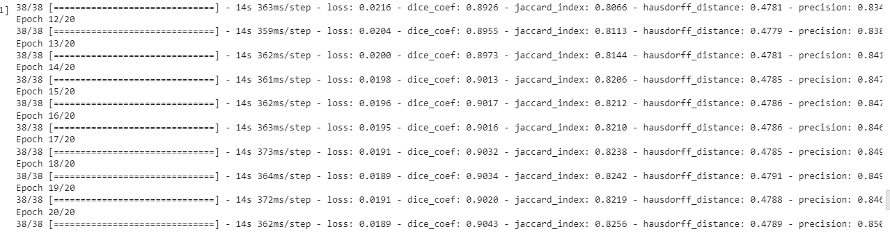

**Initially**

Epoch 1/20 38/38 [==============================] - 50s 746ms/step

- loss: 0.1928

- dice_coef: 0.4871

- jaccard_index: 0.3362

- hausdorff_distance: 0.3830

- precision: 0.5290 - recall: 0.9728

- specificity: 0.9130

- sensitivity: 0.9728

- val_loss: 0.9209

- val_dice_coef: 0.1303

- val_jaccard_index: 0.0698

- val_hausdorff_distance: 0.1742

- val_precision: 0.0675

- val_recall: 0.9998

- val_specificity: 0.0424

- val_sensitivity: 0.9998

- lr: 0.0010

**After 20 epochs**

Epoch 20/20 38/38 [==============================] - 14s 362ms/step

- loss: 0.0189

- dice_coef: 0.9043

- jaccard_index: 0.8256

- hausdorff_distance: 0.4789

- precision: 0.8503

- recall: 0.9968

- specificity: 0.9883

- sensitivity: 0.9968

- val_loss: 0.0236

- val_dice_coef: 0.9119

- val_jaccard_index: 0.8383

- val_hausdorff_distance: 0.4777

- val_precision: 0.8657

- val_recall: 0.9899

- val_specificity: 0.9894

- val_sensitivity: 0.9899

- lr: 1.4412e-05

# Results

Learning Rate Plot

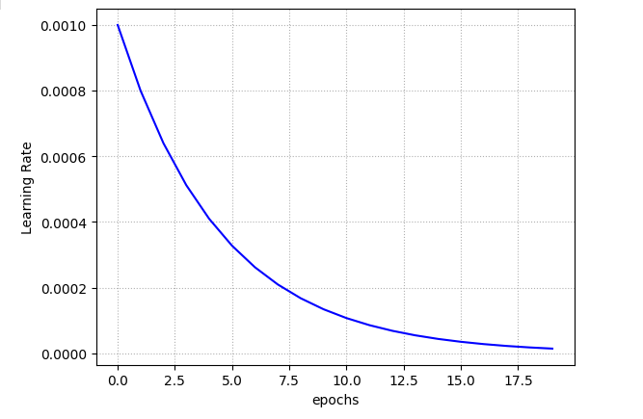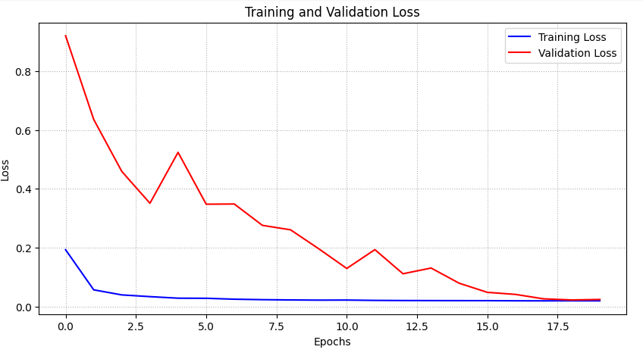Loss and Dice Coefficient Plot

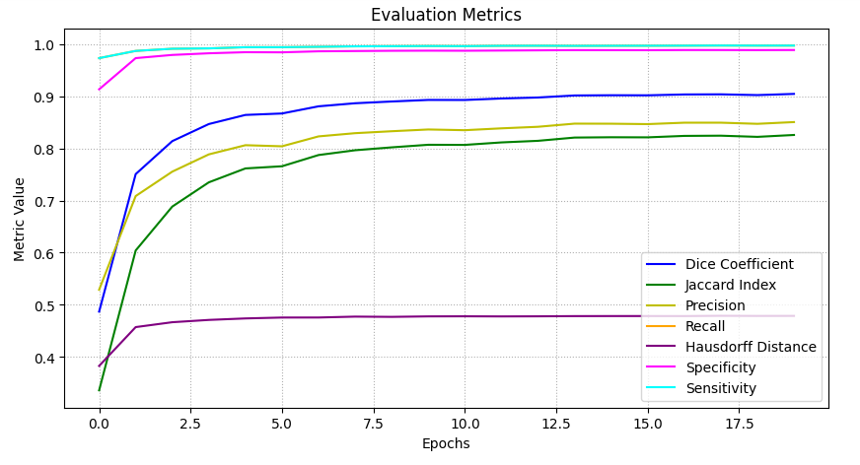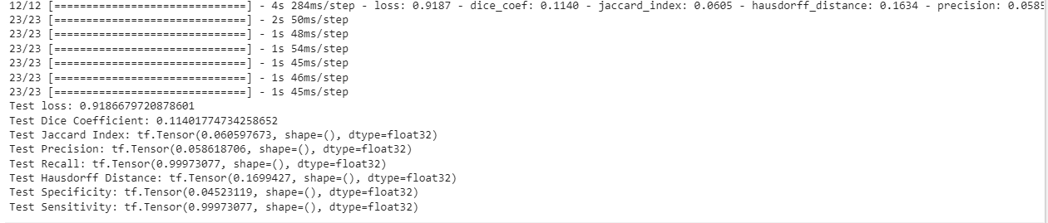

Test loss: 0.9186679720878601

Test Dice Coefficient: 0.11401774734258652

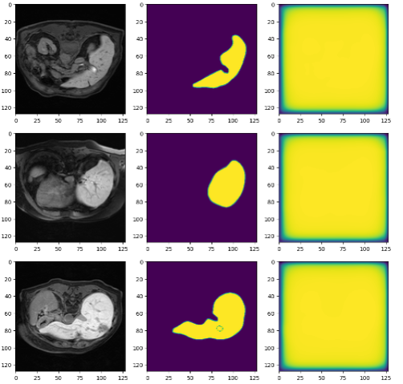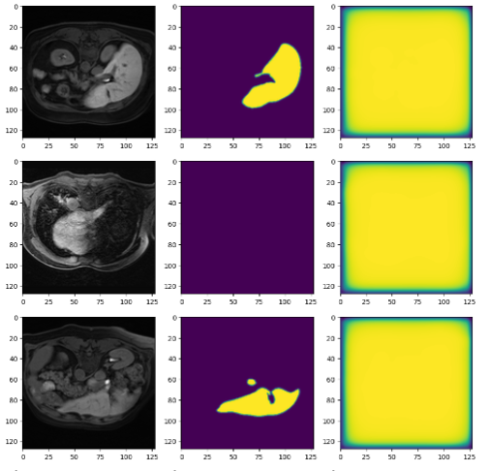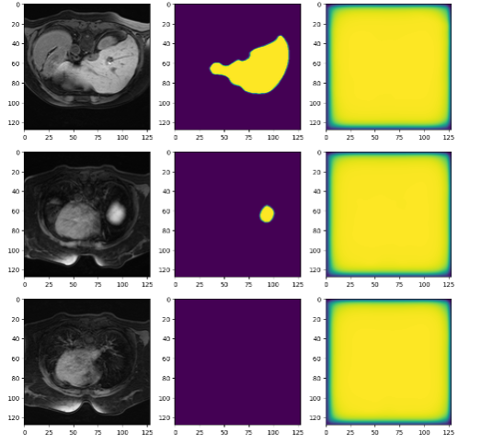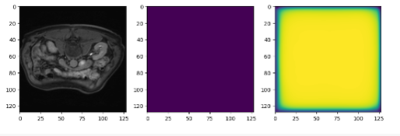

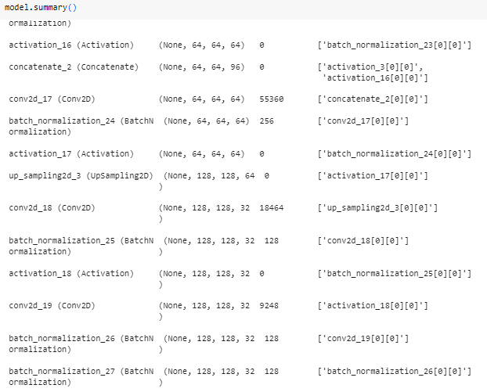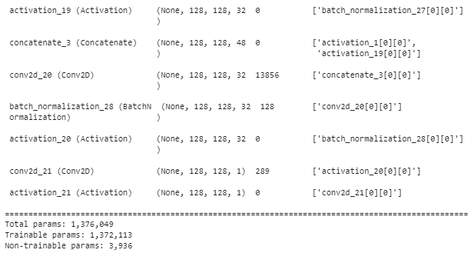

**For 10% Noise data set:**

batch_size = 64

epochs = 20

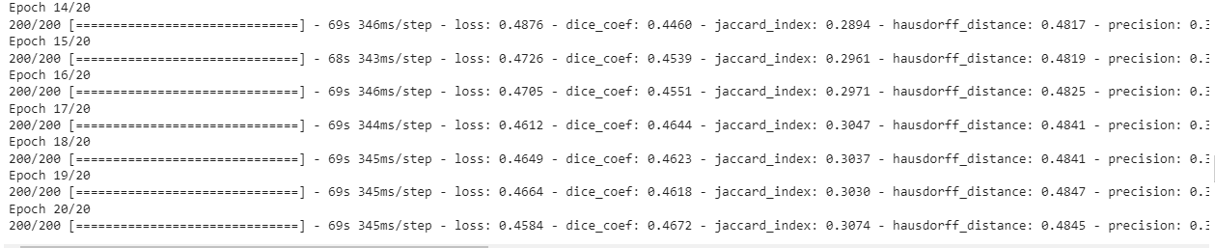

**Initially**

Epoch 1/20 200/200 [==============================] - 101s 398ms/step

- loss: 0.5918

- dice_coef: 0.3631

- jaccard_index: 0.2225

- hausdorff_distance: 0.3866

- precision: 0.2995

- specificity: 0.7856

- sensitivity: 0.5237

- val_loss: 0.8424

- val_dice_coef: 0.2134

- val_jaccard_index: 0.1211

- val_hausdorff_distance: 0.4393

- val_precision: 0.1299

- val_specificity: 0.2534

- val_sensitivity: 0.6204

- lr: 0.0010

**After 20 epochs**

Epoch 20/20 200/200 [==============================] - 69s 345ms/step

- loss: 0.4584

- dice_coef: 0.4672

- jaccard_index: 0.3074

- hausdorff_distance: 0.4845

- precision: 0.3614

- specificity: 0.7903

- sensitivity: 0.6853

- val_loss: 0.6042

- val_dice_coef: 0.3444

- val_jaccard_index: 0.2112

- val_hausdorff_distance: 0.4736

- val_precision: 0.2651

- val_specificity: 0.7422

- val_sensitivity: 0.5297

- lr: 1.4412e-05

# Results

Learning Rate Plot

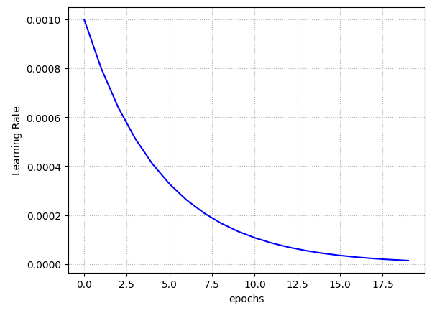

Loss and Dice Coefficient Plot

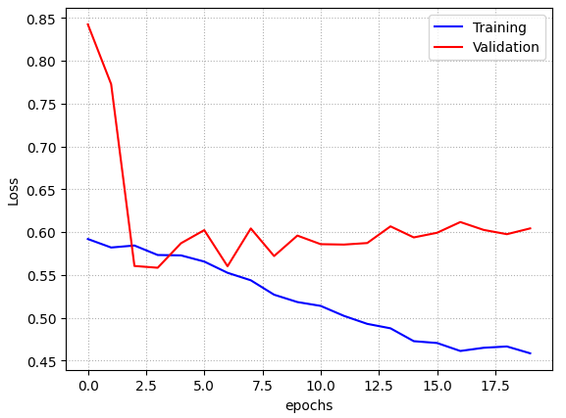



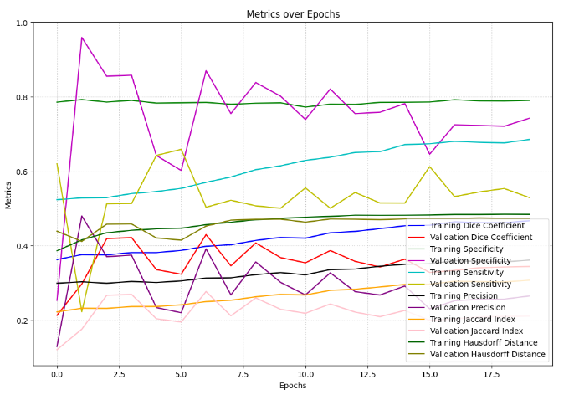



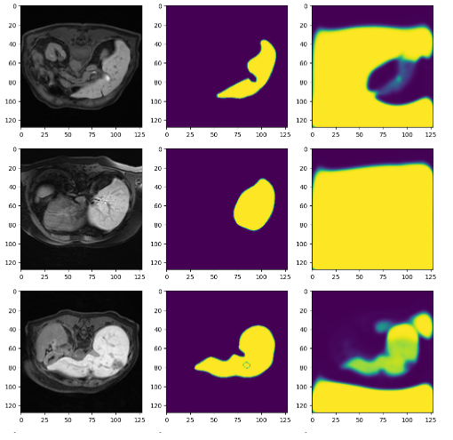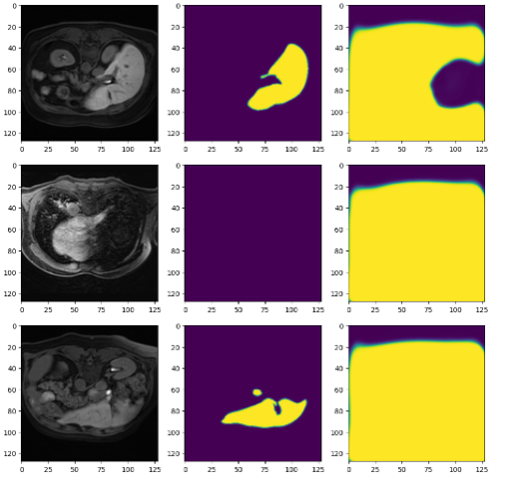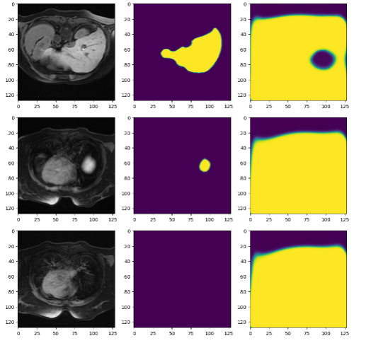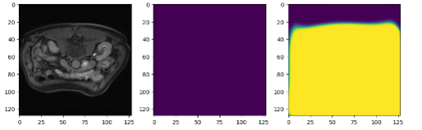

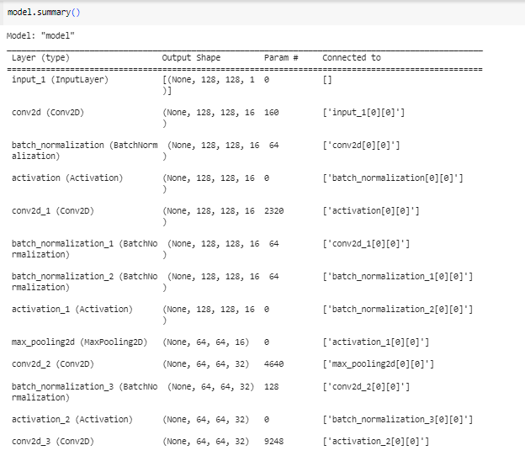.………….

**For 50% Noise in Dataset:**

batch_size = 64

epochs = 20

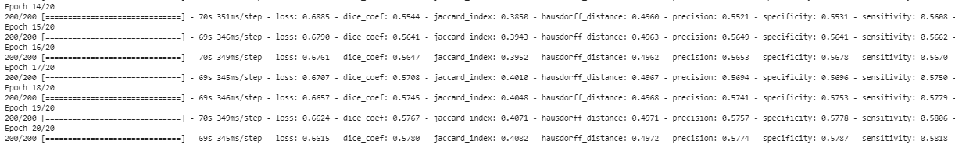

**Initially**

Epoch 1/20 200/200 [==============================] - 105s 418ms/step

- loss: 0.7510

- dice_coef: 0.4964

- jaccard_index: 0.3308

- hausdorff_distance: 0.4149

- precision: 0.4948

- specificity: 0.5176

- sensitivity: 0.4762

- val_loss: 0.9250

- val_dice_coef: 0.1400

- val_jaccard_index: 0.0753

- val_hausdorff_distance: 0.0901

- val_precision: 0.4999

- val_specificity: 0.9868

- val_sensitivity: 0.0132

- lr: 0.0010 Epoch 2/20

**After 20 epochs**

Epoch 20/20 200/200 [==============================] - 69s 345ms/step

- loss: 0.6615

- dice_coef: 0.5780

- jaccard_index: 0.4082

- hausdorff_distance: 0.4972

- precision: 0.5774

- specificity: 0.5787

- sensitivity: 0.5818

- val_loss: 0.7442

- val_dice_coef: 0.4885

- val_jaccard_index: 0.3264

- val_hausdorff_distance: 0.4950   
- val_precision: 0.5015

- val_specificity: 0.5207

- val_sensitivity: 0.4833

- lr: 1.4412e-05

# Results

Learning Rate Plot

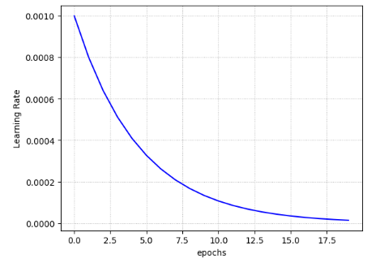

Loss and Dice Coefficient Plot

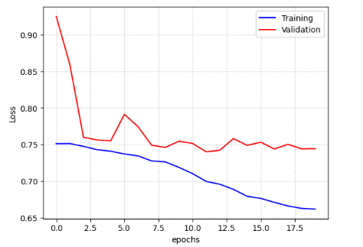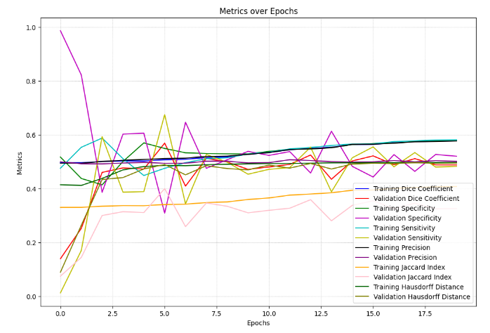



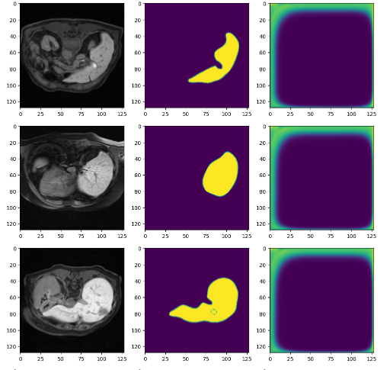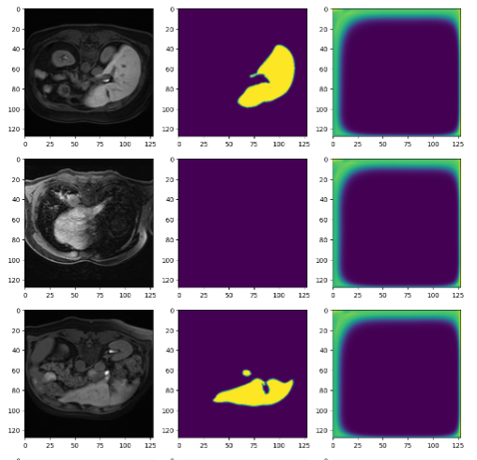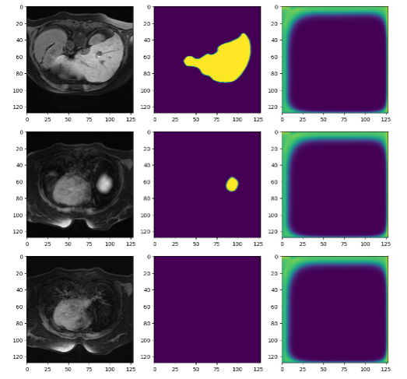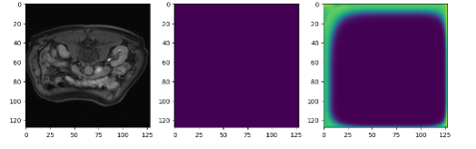

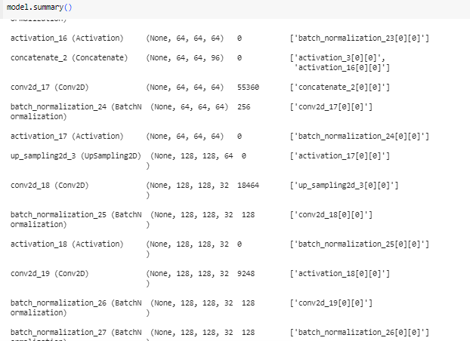

**For 70% Noise in Dataset:**

batch_size = 64

epochs = 20

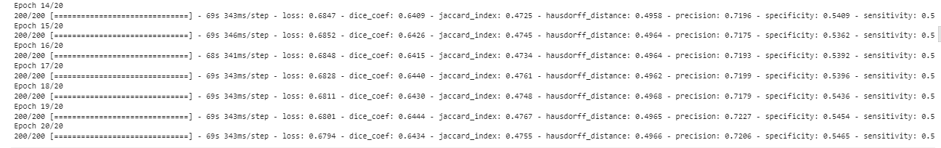

**Initially**

Epoch 1/20 200/200 [==============================] - 101s 399ms/step

- loss: 0.7199

- dice_coef: 0.6155

- jaccard_index: 0.4452

- hausdorff_distance: 0.4284

- precision: 0.6913

- specificity: 0.4295

- sensitivity: 0.6356

- val_loss: 0.7437

- val_dice_coef: 0.5092

- val_jaccard_index: 0.3418

- val_hausdorff_distance: 0.3215

- val_precision: 0.7183

- val_specificity: 0.9274

- val_sensitivity: 0.0818 - lr: 0.0010

**After 20 epochs**

Epoch 20/20 200/200 [==============================] - 69s 343ms/step

- loss: 0.6794

- dice_coef: 0.6434

- jaccard_index: 0.4755

- hausdorff_distance: 0.4966

- precision: 0.7206

- specificity: 0.5465

- sensitivity: 0.5833

- val_loss: 0.7270

- val_dice_coef: 0.7051

- val_jaccard_index: 0.5466

- val_hausdorff_distance: 0.4967

- val_precision: 0.7168

- val_specificity: 0.3911

- val_sensitivity: 0.7002

- lr: 1.4412e-05

# Results

Learning Rate Plot

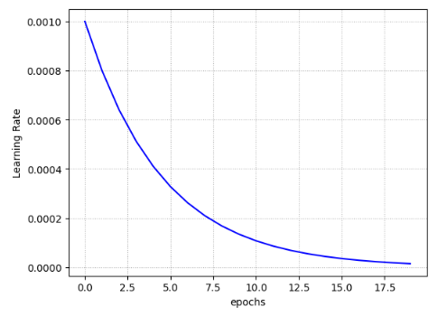

Loss and Dice Coefficient Plot

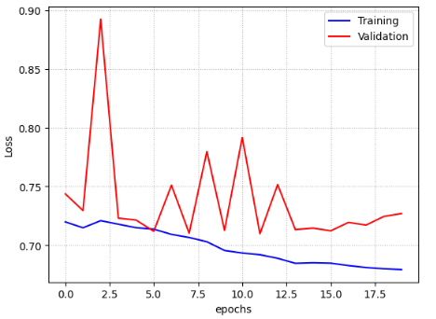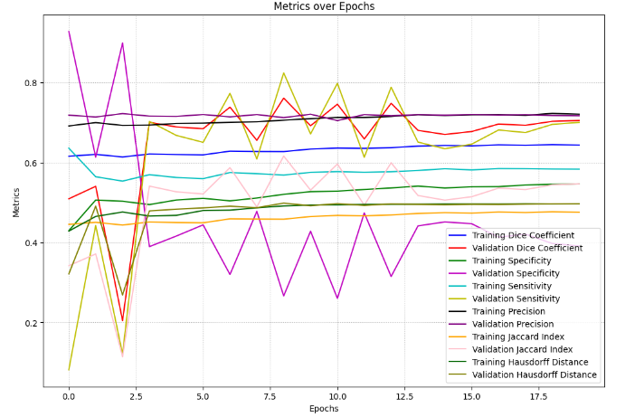



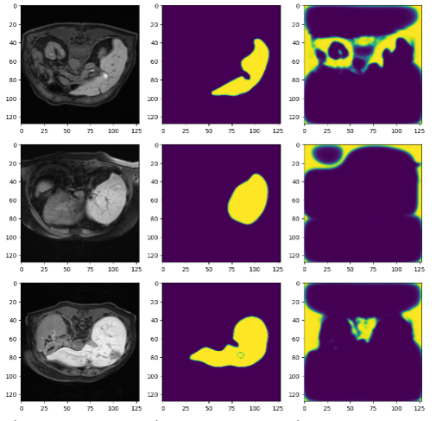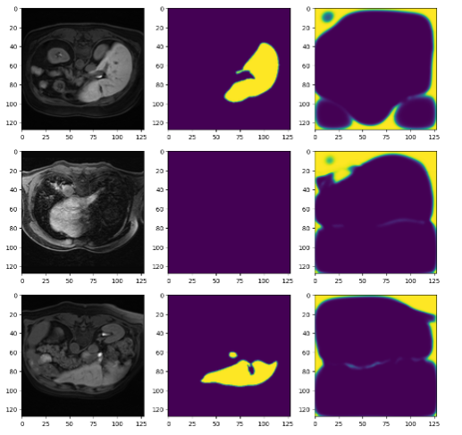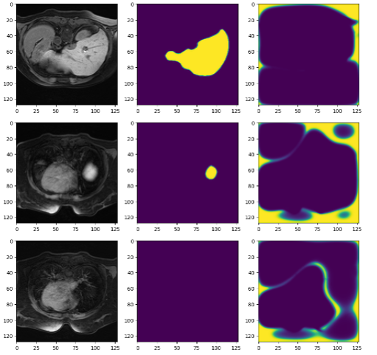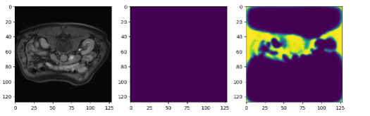

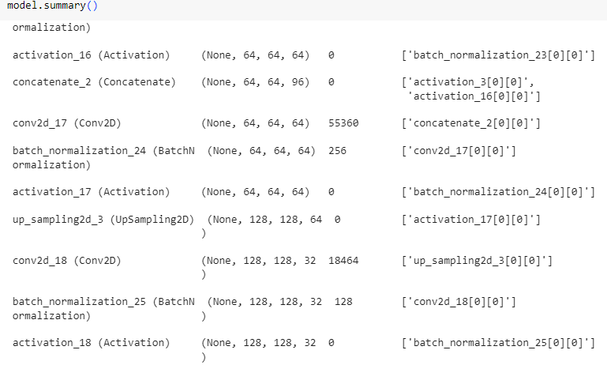

**Conclusion:**

**Sensitivity-Specificity loss performance**

**For clear data set:**

After 20 epochs

Dice_coeff =0.9043

Loss =0.0189

Test loss: 0.9186679720878601

Test Dice Coefficient: 0.11401774734258652

**For 10% noise data set:**

After 20 epochs

Dice_coeff =0.4672

Loss =0.4584

Test accuracy =0.080868873733282889

**For 50% noise data set:**

After 20 epochs

Dice_coeff =0.5780

Loss =0.6615

Test accuracy =1.987498762900941e^-06

**For 70% noise data set:**

After 20 epochs

Dice_coeff =0.6434

Loss =0.6794

Test accuracy =0.0009850735077634454